Help us spread the message that could save people’s lives this bushfire season…

You CANNOT rely on scheme water during a bushfire
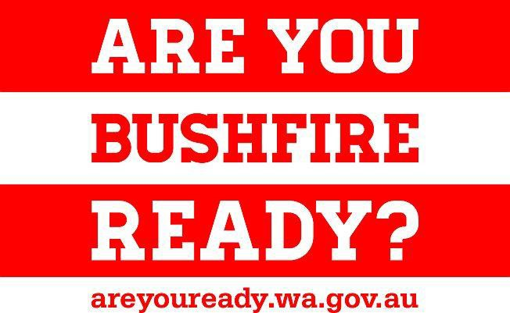Residents living in or near bushland are reminded that they cannot rely on public water supplies if they plan to stay and defend their homes during a bushfire.

If you plan to stay and defend your home you must have an INDEPENDENT water supply and pumping capability. Scheme water may not be available due to damaged infrastructure, extreme demand depleting supply and pressure, or a cut to power which is used to pump water.

Water Corporation has made preparations for the 2016-17 bushfire season by readying equipment and systems to cope with extreme conditions. Despite these efforts, it is likely there will be a reduction in water pressure, and scheme water supply tanks may run empty in the event of fire.

For more information about preparing a bushfire survival plan and what you will need to actively defend your home, visit the Department of Fire and Emergency Services website www.emergency.wa.gov.au/prepare

A message from the Department of Water
The Department of Water has advised people in bushfire prone areas with bores and access to surface water that they can take and store water to support bushfire plans.

For more information on how the Department of Water’s rules support bushfire preparedness, visit www.water.wa.gov.au/fireplanning

Emergency Numbers
Fire or life threatening emergencies | 000
SES Emergency Assistance | 132 500
Emergency Information | 13 DFES (13 13 37)

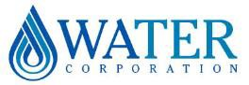watercorporation.com.au
#15879945

