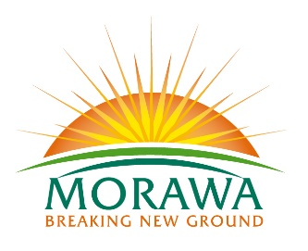

LOCAL GOVERNMENT ACT 1995
BUSH FIRES ACT 1954
CEMETERIES ACT 1986
DOG ACT 1976

Shire of Morawa
Proposed Local Laws

The Shire of Morawa proposes to make the local laws as listed below.

- Bush Fire Brigades Local Law 2018
Purpose – to make provisions for establishment, management and administration of Bush Fire Brigades.
Effect – to align the requirements for Bush Fire Brigades with legislation and general practice.

- Dogs Local Law 2018;
Purpose – to make provisions about the impounding of dogs, the number of dogs that may be kept on premises and the manner of keeping dogs and create offences for non-compliance
Effect – to repeal existing Dogs Local Laws and extend the controls over dogs which exist under the Dog Act 1976.

- Extractive Industries Local Law 2018;
Purpose – to establish requirements and conditions which extractive industries within the Shire must comply
Effect – to provide for the regulation, control and management of extractive industries

- Fencing Local Law 2018;
Purpose – to prescribe a sufficient fence and the standard for construction of fences
Effect – to establish the minimum requirements for fencing, provide for permitted and prohibited fencing, and create offences for non-compliance.

A copy of the proposed local laws may be inspected at or obtained from –
- the Shire Office, 26 Winfield St, Morawa during normal office hours
- by contacting the Shire Office

Submissions about the proposed local laws may be made by 4.30pm, Friday 27 April 2018 –
- in writing to the CEO, or
- by email to admin@morawa.wa.gov.au

C. Linnell
Chief Executive Officer

